You may choose the YouTube or Audio/SoundCloud version of the show. Both are here:

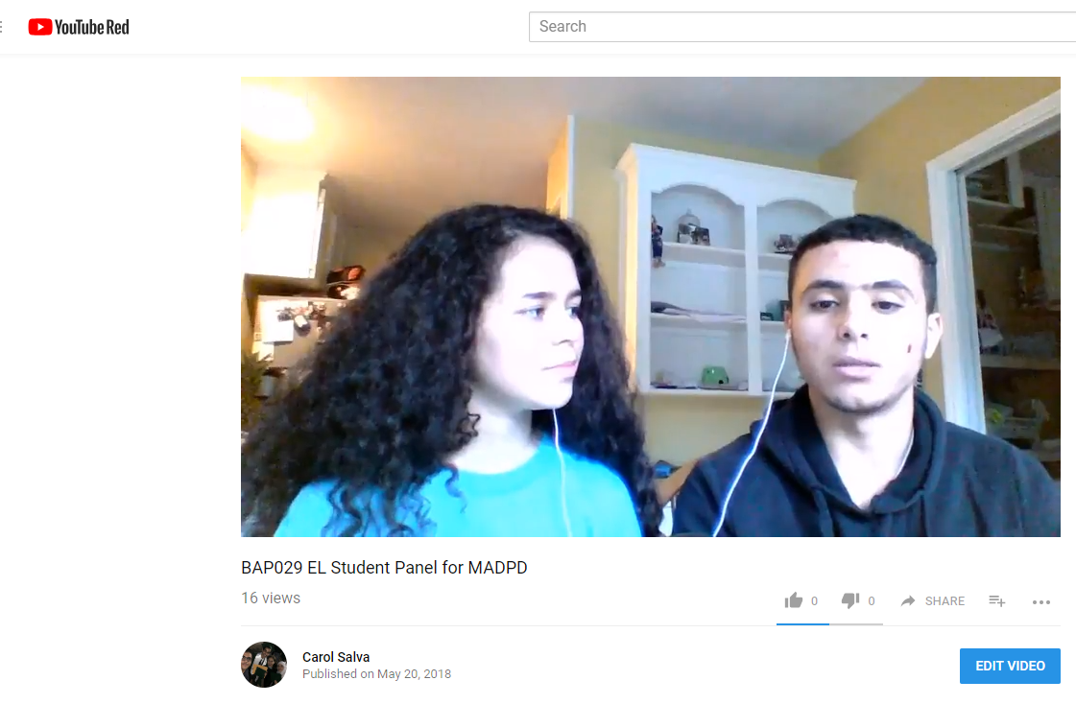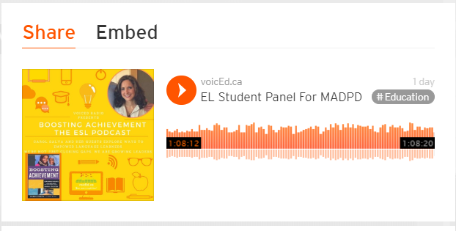

CONTENT OBJECTIVE:
We will watch this 1-hour EL Student Panel and reflect on how their perspective supports best practice for sheltered instruction and inclusion.

LANGUAGE OBJECTIVE:
I will reflect in writing using language such as:
Rigor Hope Faith in your students Visuals and Gestures Reading Creating a safe place Motivation - Relatedness/Relationships
Motivation - Competence Growth Mindset Collaboration

These are three new arrival students who come from challenging circumstances. Some have missed years of formal education, one is a refugee and all were new to English when they arrived in high school. Your objective is to be able to write a reflection on one or more of the following:

- Mainstream teachers were mentioned. How did they contribute to the growth mindset of these learners? What did they do specifically and what connections can you make?
- This ESL teacher did not have common planning time with their content teachers. What are some examples of what she did to support not only language but also content learning in her ESL classroom?
- All three of the students talk about relationships with teachers. What advice do they give that isn't part of our content curriculum? What stood out to you?
- Some would say that these practices are "just good teaching." But there are many "good teaching" strategies that are not essential for ELs. Please reflect on which of the techniques mentioned by the students are critical for language learners, and easy to implement in our classrooms.
- Any other take-away that you feel will impact your practice. Please explain your reflection and your first three moves to implement what you’re thinking.

